New York Outdoor Quarterly Magazine (Summer 2005 Volume 1, Issue #2)

Long Island Jetty Fishing 101
By Steve Knapik - NYS Licensed Fishing Guide #4321
June, 2005
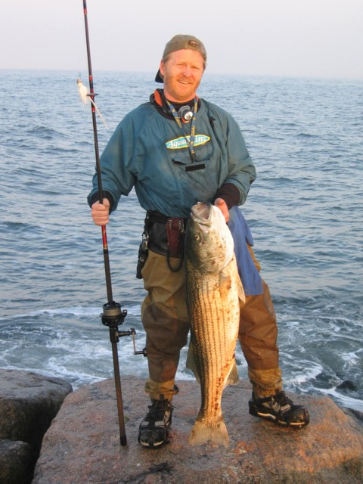

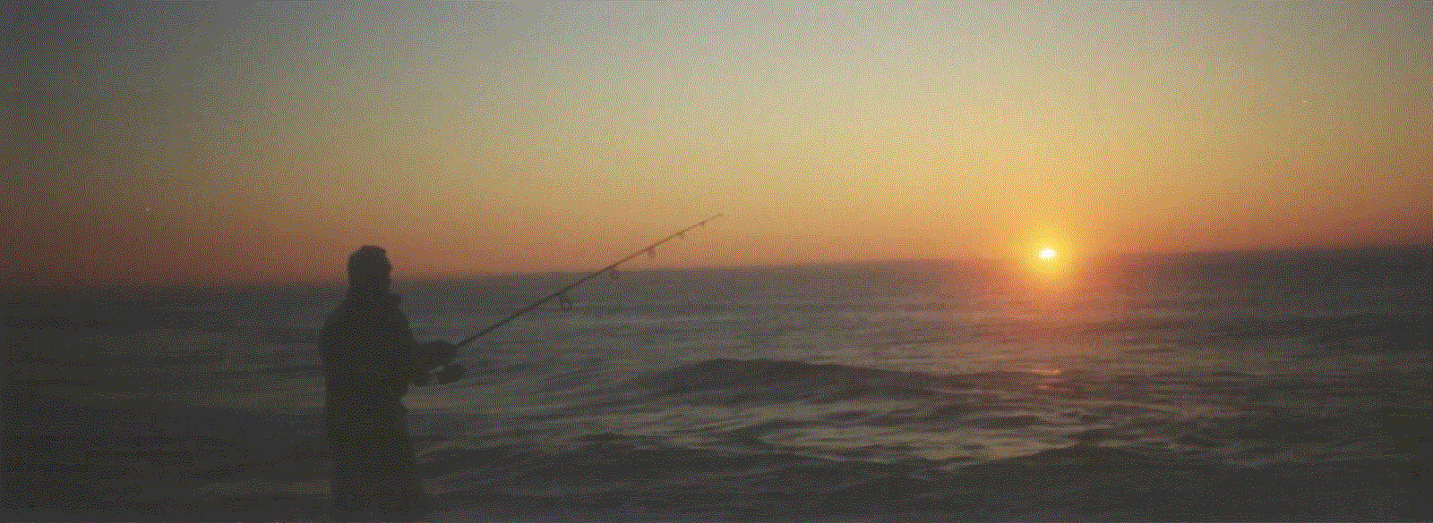

Now that the long cold winter has passed the mild days and nights of late spring and early summer are upon us, it’s time to target striped bass. During the early spring months the water temperatures of Long Island’s south shore beaches and inlets are cold enough to keep most striped bass lethargic and uninterested in most artificial presentations from the surf, however late May to mid July is another story. The water temperatures during these late spring and early summer months rise rapidly from 58 degrees to about 69 degrees. These temperatures are ideal for targeting striped bass in deep moving water and rips.

One of Long Island’s most productive areas for catching striped bass as well as bluefish and weakfish are its jetties and groins that dot along our south shore beaches from Brooklyn to Montauk Point. Why should I fish a jetty you ask? The key word is structure.

Understanding Jetties

A jetty is a rocky manmade structure built usually near an inlet or harbor for the purpose of erosion control and protection of our barrier beaches. These rocky structures encourage the growth of moss, algae and other marine plants as they pass by in the ocean current. Mussels attach themselves to these rocks to feed on this marine vegetation. Blackfish and other baitfish feed off of the mussels. In addition during the months of late May to mid July the water around these jetties are teaming with menhaden (bunker), shad, sand eels, fluke and other delectables. Striped bass love to eat these fish buffet style and they will use these jetties as a place to hide, hunt, feed and rest. These jetties create a perfect food chain environment.

The areas around our south shore beaches, inlets, bays and jetties have been known to hold striped bass over 50 pounds. Striped bass owe there size not to ferocious feeding like bluefish, but to their smart hunting: they don’t like to expend a lot of calories chasing down their meals. They take full use of a jetty’s structure to hide in the shadows of submerged rocks, the turbulence of moving water, and the darkness of night to seek out their next meal.

Surfcasting around Long Island jetties can be tricky, dangerous, yet fruitful to the skilled jetty jockey. Striped bass love structure and moving water, these rocky manmade formations present rips, deep holes and hiding areas for baitfish. When fished correctly jetties can be a hidden treasure chest for the surf fisherman.

You will find that fishing jetties during this short window period of late May to mid July and again in the cool fall months of September through early December are one of the best and most productive areas that consistently produce striped bass weighing anywhere from a few pounds to 30 + pounds.

During the warmer months of late July to late August, also known as the summer doldrums, the water temps are very warm and the striped bass have a tendency to move into deeper and cooler water waiting for their fall migration clock to start. Now is the time to hit the rocks and take advantage during this primetime season.
Whether you are a newbie surf fisherman or an old time sharpie surf rat, you should always take the time to plan your trip. I have seen many a surf rat fish unprepared, and as a result they either got skunked or in some cases injured. If you plan well and fish smart then I can guarantee that you will score fish consistently.

Where are these Jetties located?
Most of the better jetties that produce large fish are located near deep water inlets. Traveling west to east along Long Island’s south shore you will find several of these fishing playgrounds. Some of the best are; Breezy Point Jetty near Rockaway Inlet, Silver Point Jetty in Atlantic Beach, as well as many of the jetties and groins that dot Long Beach and the Point Lookout communities. Traveling further east you have the West End 2 jetty located at the Jones Beach Inlet, Democrat Point sidewalk jetty located near the mouth of Fire Island Inlet, Moriches Inlet jetty and the Shinnecock Inlet jetty near eastern Long Island. Each one of these jetties is unique amongst themselves and offer different challenges during the season and weather conditions. With that said, please be careful when fishing them for the first time.
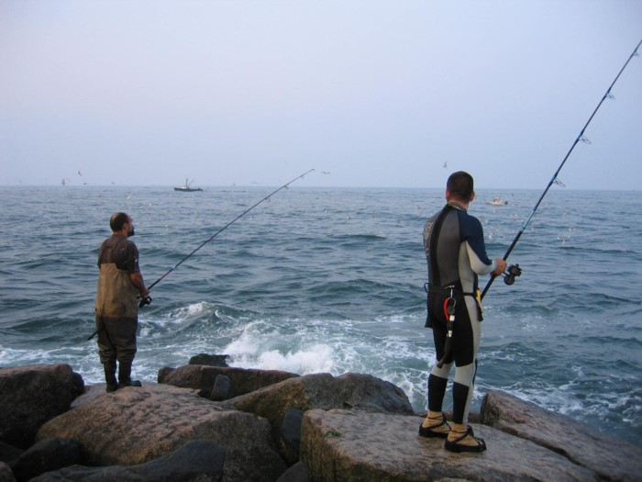

Think Safety First
Regardless of the type of jetty you fish you MUST ALWAYS keep safety as your first priority. Remember no fish, no matter how large it is, is worth your life! My safety tips are not meant to scare you, but they are meant to keep you aware of potential dangers while jetty fishing.

Long Island’s jetties can extend out well over a hundred yards into a rough ocean on one side and a deep fast moving inlet on the other. Jetties can be slippery with jagged rocks and wide deep crevices, or they can be high, flat and relatively dry during calm seas.

Safety Tips
Do not fish in areas that you are unfamiliar with. Check out the jetty first at daylight during both low & high tide to understand the layout.

If possible fish with a buddy who knows the area. As the ole saying goes; “There is safety in numbers”.

Listen to the marine forecast before venturing out onto a jetty. Excessive high seas/winds or lightning can be extremely dangerous.

Always let someone know where you are fishing and your approximate time of return.

If possible avoid wearing chest waders on a jetty. Should you become submerged they can get you in trouble. Consider wearing an inflatable fishing vest for added safety.

Wearing metal cleats or Korkers is a MUST when rock hopping. Although they will not always keep you from slipping on a rock they will certainly give you an extra advantage.

Carry a neck light or head lamp since most of your jetty fishing will be during the night or first light hours.

Carry a cell phone wrapped in a water tight bag.

Carry a whistle. Should you get in trouble the sound of a whistle will travel further than your voice.

Carry a small basic first aid kit with you.

During those hot summer nights don’t forget to bring water. Some jetties require a 1 mile or more walk to get to.

Last but not least don’t forget the insect repellant. West Nile and Lyme disease are frequent visitors to our Island.

Equipment Needs
Always check the local ordinances and needed permits regarding use of town, county or state beaches. Some beaches require a nighttime fishing permit while others may have residency requirements.

Surf fishing spinning rod/reels
Since I build my own rods, my set up is a Lamiglas GSB 1201M spinning rod matched with a Van Staal 250b spinning reel. This is my go to rod for both jetty and open beach surf fishing conditions. I don’t recommend fishing a jetty with anything less than a 9’ medium action rod. The shorter the rod the more difficulty you will have landing a large fish. I also don’t recommend fishing with a rod longer than an 11’. Anything longer might get in your way should you have to climb down a rocky jetty to retrieve a fish.

When purchasing a fishing rod you don’t need to spend a lot of money. You should find one that fits your needs based on your height, weight, experience and relative strength. However, I do recommend surf fishing with a sturdy spinning fishing reel. A Penn Spinfisher 704z is a great example of a reel that will provide you with many years of reliable performance that won’t drain your life savings.

Line choice
Since the new advances in microfilament fishing line a.k.a. “braided fishing line” the need for monofilament fishing line has nearly become obsolete for the surf fisherman using a spinning reel. I have been using Power Pro 50# microfilament fishing line on my spinning reels for about five years. These braided lines have many advantages such as decreased diameter when compared with comparable monofilament fishing line. 50# braided line has a diameter equal to 12# monofilament line. What does this mean for you? It usually means you will be able to cast your line further with more accuracy. Since braided lines have no “memory” you will have an improved feel for your lure and solid hook sets that don’t require you to jerk your rod like you’re landing an elephant. However these “braided fishing lines” are not cheap. They can cost $30.00 for a 300 yd. spool.

If you prefer to fish with less expensive monofilament fishing line then my recommendation would be to use Ande 20# pink. This line holds up well in the harsh jetty environment but it may need to be changed more frequently during the fishing season.

Leaders
Always use a leader! Use a 30 to 40 inch, 50# to 60# monofilament or fluorocarbon leader with a barrel swivel, either tie your lure directly to the leader or use a duo snap rated no less than 50#’s. Using a leader is necessary to prevent early line failure and it will improve your hook ups and hook set when you nail the big one! For an added enticement trying attaching a teaser hook half way up your leader. It is not uncommon to nail two bass on one line, just be prepared to have the drags on your reel smoked!

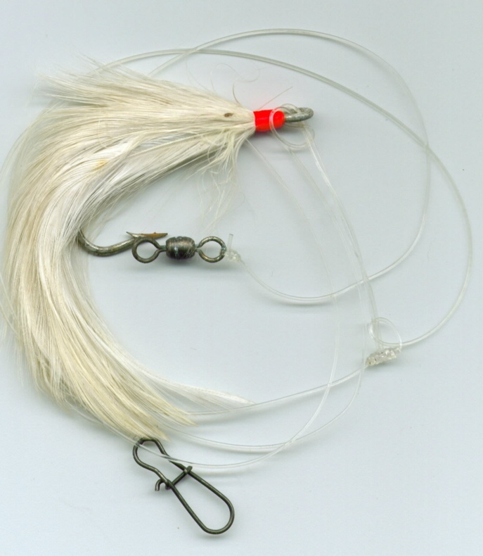
Teaser rig

Lures vs. bait
Outside of casting live eels, it has always been my opinion that bait fishing does not belong on a jetty. The fast moving currents and wave action make bait fishing rigs difficult to hold bottom and very annoying for those who are fishing artificials. It is for those reasons that bait fishing will not be discussed here.

Bucktails are the number one go to lure when jetty fishing. Nearly 90% of all my keeper striped bass were captured using bucktails. This doesn’t mean that bombers, darters, tins or poppers don’t work well, they do, but it has been my experience that the bucktail will have the highest hookup ratio than any other artificial lure when fishing a jetty. The bucktail has the versatility to mimic small wounded baitfish such as shad, bunker, and sand eels.

For jetty casting the two most productive bucktails are the “Andrus Jetty Caster” and the “Smiling Bill”. The Andrus Jetty Caster is dense with a large amount of deer hair allowing it to drift slowly to the bottom. The “Smiling Bill” with its notched mouth works best in fast moving water and rips. During late May and mid July white, yellow and chartreuse colored bucktails are some of the best all-round colors to fish with. Not only do these particular bucktails nail striped bass consistently, they seem to do their fair share catching tiderunner weakfish and hungry bluefish.

Bucktails should always be fished with a tail dressing I.e. pork rind, or plastic curly tails. One of the most productive dressings is the Uncle Josh Striper Sea Strip # 70-s in white or red color it is 5 ¼” x 5/8” in size. I am partial to the red color over the white this time of year. You can also split the pork rind with a razor for added enticement or you can use the Uncle Josh Striper Sea Strip # 270 “striper split tail”.
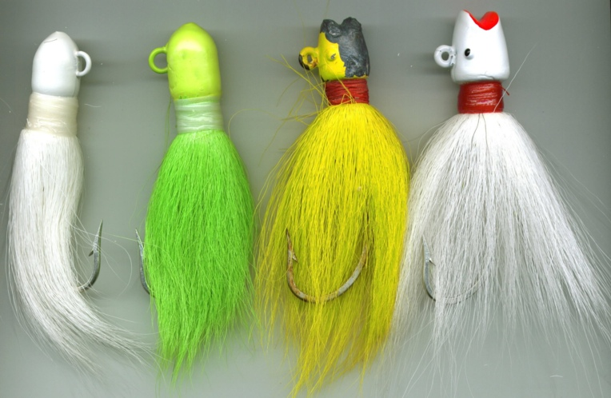
Bucktails

How do I determine what size bucktail to use? Depending upon water conditions the need for heavier bucktails can vary. Generally 1 1/2 oz. to 2 1/2 oz. will handle average to heavy water conditions on most jetties. If fast heavy water is present it may be necessary to use bucktails 3 ounces or more.

When is the best time to jetty fish bucktails?
If you want to catch large striped bass on a consistent basis during mid May to mid July my answer to you would be to fish when the sun is down. Striped bass are nocturnal feeders. This means that striped bass hunt primarily at night. This certainly doesn’t mean you can’t catch them during the day, but most of your larger fish will be caught in the dark and wee hours.

Look for patterns and “fish the tides”.
It is important to take the time to fish all the various tides/moon phases and weather conditions. You want to look for patterns as they develop during this period. You may find that the bass were hitting on the top of the flood tide or 2 hours into the ebb. These patterns seem to be consistent for days at a time depending upon the tidal flow. Track these patterns by keeping a detailed fishing log.

If you are new to this type of fishing then it is my recommendation that you first try fishing 2-3 hours before and after high tide. This way you get the benefit of both fast moving and deep water both incoming and outgoing tides. During the late spring to early summer, fish 1 hour before first light to sunrise. Mid summer is strictly a night game or wee hour’s game due to the extreme daytime heat. Try fishing the top of the tide to the outgoing tide. The water is cooler and fish will congregate by a jetty that is near a deep water inlet.

How do you fish a bucktail?
Jetties that border an inlet will usually provide fast moving water and rips depending upon the tidal flow. Now you ask me. What is a rip? Simply put a rip is when a body of water must pass over or around an underwater obstruction such as a sandbar or large rock. As the water passes over or around this obstruction a more turbulent condition will exist on the surface. Larger striped bass will park themselves near the bottom of this water column facing into the current waiting for bait fish to pass over the obstruction (rip).

You should always cast your bucktail 45°up current near the edge of a rip or deep water trough and allow the bucktail to slowly sink to the bottom. Quickly reel in any slack in the line. First, using a slow retrieve with a periodic twitch to the rod tip will cause the bucktail to mimic a wounded baitfish. A slow retrieve will keep the bucktail close to the bottom of the water column where the larger striped bass feed. You can also vary the speed of your retrieves until you find the one that provokes a strike. But don’t retrieve to fast or you will be catching more bluefish than striped bass. Also, try varying the distance of your cast. You might find striped bass closer to the jetty than you first thought. If you don’t get a “hit” after 15 or 20 minutes, move to another area on the jetty or fan cast in other directions. You want to find that strike zone.

Setting the hook & controlling the fish for a quick, safe landing!

If you should get a “hit” be prepared to quickly set the hook with a quick jerk of your rod tip. (Keep your drag somewhat tight) Once you have set the hook be prepared to slightly loosen your drag enough to keep the fish from snapping your line or rod. Striped bass tend to be powerful but short distance swimmers. The bass may make two or three “runs” before it tires out. Bring the fish into an area free from heavy pounding waves! If necessary carefully climb down the jetty while keeping a firm grip on your rod without giving any slack to the fish, or if possible “walk” the fish to the open sand beach. Using a Boga Grip or other grabbing device quickly grab the striper by the lower jaw and gently lift it to a safe area for keep or release. For small bass you can certainly use your hands, just watch out for a flailing fish and sharp hooks! It helps to have a buddy spot you while you are recovering the fish. Time is crucial to the life of these stripers. If you plan on releasing your catch avoid overplaying them. Larger striped bass tend to build lactic acid in their muscles quickly. That’s why it’s important to retrieve, revive and release the fish quickly. Make sure the fish is ready to be released by moving water over its gill plate or until it makes a move to swim away. A tired fish, if not released properly will drown.

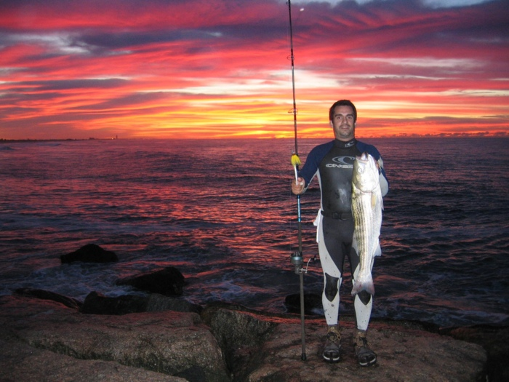
Early Morning Bass

New York State Rules and Regulations
One of the most embarrassing and expensive mishaps to a new angler is getting caught by a conservation officer for either keeping an undersized striper or more than the legal limit allows. In New York State, Striped bass in waters south of the George Washington Bridge from April 15 to December 15 the possession limits are as follows: Two fish per person (in possession) per day one being between 28” and 40”, and one fish being greater than 40 inches. Measurements of the fish are taken with the jaws closed, to the tip of the tail.

With this said, please practice conservation. Take only what you need and leave the rest. Conservation is everyone’s responsibility! Let’s give future generations of surf rats a healthy and vibrant marine environment to fish from.

As the sun slowly rises in the east and your time at fishing the jetty closes take a moment to be thankful for your beautiful surroundings. Even if you don’t catch a thing that particularly morning remember that patience and fortitude will eventually pay off.

In summary, what did you learn?
- Jetties are one of the most productive area for targeting Striped Bass on Long Island during the early summer and fall months
- Practice Safety & Common Sense!
- Bucktails are the #1 lure when fishing jetties
- Look for patterns and fish the tides
- Keep a log
- Always practice conservation
- Have Fun and Fish Smart

